Assignment 3

CMSC 691 — Computer Vision

Faisal Rasheed Khan

VB02734

[vb02734@umbc.edu](mailto:vb02734@umbc.edu)

**Question 1-----------------------------------------------------**

1. Homogeneous 3x3 matrix with angle $θ$ at point (a,b)

Deriving homogeneous transformation for rotating a point (x,y) around specific point (a,b) with angle $θ$, it involves 3 transformations.

1. Translation of (x,y) that move (a,b) to origin
2. Rotation around the origin w.r.t $θ$
3. Translation back to original position
4. Translate point (x,y) such that (a,b) moves to origin

T1 =

1. Rotation around the origin w.r.t $θ$

R = $\left[\begin{matrix}\cos{ θ} & -sin θ & 0 \\ sin θ & cos θ & 0 \\ 0 & 0 & 1\end{matrix}\right]$

1. Translation back to original position

T2 =

Overall,

M = T2 * R * T1 =

M =

M =

M =

=

1. P1 = (1,1), P2 = (2,1), P3 = (2,2), P4 = (1,2)

At point P2 = (2,1) rotation with 45 degrees.

The matrix form can be written as,

$\left[\begin{aligned}x^{1} \\ y^{1} \\ 1\end{aligned}\right]$ = $\left[\begin{matrix}\cos{ θ} & -sin θ & -a cos θ+b\sin{θ+a} \\ sin θ & cos θ & -a\sin{θ}-b\cos{θ}+b \\ 0 & 0 & 1\end{matrix}\right]$ $\left[\begin{aligned}x \\ y \\ 1\end{aligned}\right]$

We have (a,b) = (2,1),

$\left[\begin{aligned}x^{1} \\ y^{1} \\ 1\end{aligned}\right]$ = $\left[\begin{matrix}\cos{ 45} & -sin 45 & -2 cos 45+\sin{45+2} \\ sin 45 & cos 45 & -2\sin{45}-\cos{45}+1 \\ 0 & 0 & 1\end{matrix}\right]$ $\left[\begin{aligned}x \\ y \\ 1\end{aligned}\right]$

$\left[\begin{aligned}x^{1} \\ y^{1} \\ 1\end{aligned}\right]$ = $\left[\begin{matrix}\frac{1}{\sqrt{2}} & -\frac{1}{\sqrt{2}} & -2 \frac{1}{\sqrt{2}}+\frac{1}{\sqrt{2}}{+2} \\ \frac{1}{\sqrt{2}} & \frac{1}{\sqrt{2}} & -2\frac{1}{\sqrt{2}}-\frac{1}{\sqrt{2}}+1 \\ 0 & 0 & 1\end{matrix}\right]$ $\left[\begin{aligned}x \\ y \\ 1\end{aligned}\right]$

$\left[\begin{aligned}x^{1} \\ y^{1} \\ 1\end{aligned}\right]$ = $\left[\begin{matrix}\frac{1}{\sqrt{2}} & -\frac{1}{\sqrt{2}} & \frac{-1+2 \sqrt{2}}{\sqrt{2}} \\ \frac{1}{\sqrt{2}} & \frac{1}{\sqrt{2}} & \frac{-3+ \sqrt{2}}{\sqrt{2}} \\ 0 & 0 & 1\end{matrix}\right]$ $\left[\begin{aligned}x \\ y \\ 1\end{aligned}\right]$

$\left[\begin{aligned}x^{1} \\ y^{1} \\ 1\end{aligned}\right]$ = $\left[\begin{aligned}\frac{x - y -1+2 \sqrt{2}}{\sqrt{2}} \\ \frac{x + y -3+ \sqrt{2}}{\sqrt{2}} \\ 1\end{aligned}\right]$

Substitute all the points in the above matrix form to get the new points,

$P1$ = (1,1)

$P_{1}^{'}$ = $\left[\begin{aligned}\frac{1 - 1 -1+2 \sqrt{2}}{\sqrt{2}} \\ \frac{1 + 1 -3+ \sqrt{2}}{\sqrt{2}} \\ 1\end{aligned}\right]$

$P_{1}^{'}$ = $\left[\begin{aligned}\frac{2 \sqrt{2} - 1}{\sqrt{2}} \\ \frac{\sqrt{2}-1}{\sqrt{2}} \\ 1\end{aligned}\right]$

$P_{1}^{'}$ = ( $\frac{2 \sqrt{2} - 1}{\sqrt{2}}$, $\frac{ \sqrt{2} - 1}{\sqrt{2}}$)

$P2$ = (2,1)

$P_{2}^{'}$ = $\left[\begin{aligned}\frac{2 - 1 -1+2 \sqrt{2}}{\sqrt{2}} \\ \frac{2 + 1 -3+ \sqrt{2}}{\sqrt{2}} \\ 1\end{aligned}\right]$

$P_{2}^{'}$ = $\left[\begin{aligned}2 \\ 1 \\ 1\end{aligned}\right]$

$P_{2}^{'}$ = (2,1)

$P3$ = (2,2)

$P_{3}^{'}$ = $\left[\begin{aligned}\frac{2 - 2 -1+2 \sqrt{2}}{\sqrt{2}} \\ \frac{2 + 2 -3+ \sqrt{2}}{\sqrt{2}} \\ 1\end{aligned}\right]$

$P_{3}^{'}$ = $\left[\begin{aligned}\frac{2 \sqrt{2} - 1}{\sqrt{2}} \\ \frac{\sqrt{2} + 1}{\sqrt{2}} \\ 1\end{aligned}\right]$

$P_{1}^{'}$ = ( $\frac{2 \sqrt{2} - 1}{\sqrt{2}}$, $\frac{ \sqrt{2} + 1}{\sqrt{2}}$)

P4 = (1,2)

$P_{4}^{'}$ = $\left[\begin{aligned}\frac{1 - 2 -1+2 \sqrt{2}}{\sqrt{2}} \\ \frac{1 + 2 -3+ \sqrt{2}}{\sqrt{2}} \\ 1\end{aligned}\right]$

$P_{4}^{'}$ = ( $2-\sqrt{2}$, 1 )

1. $x^{1}$ = a x + b y + tx + +

= c x + d y + ty + +

To find point of correspondence we need to do ” Ah = 0 “

The above equations can be written in the matrix form as,

[ $\begin{matrix}x y 0 0 1 0 x^{2} y^{2} 0 0 \\ 0 0 x y 0 1 0 0 x^{2} y^{2}\end{matrix}$] * [ a b c d tx ty α $β$ $γ$ θ ]T

A * h = 0

Solve for A*h = 0,

We have 10 unknowns to solve and we need atleast 5 correspondence points to solve the problem.

1. Qudrilateral:

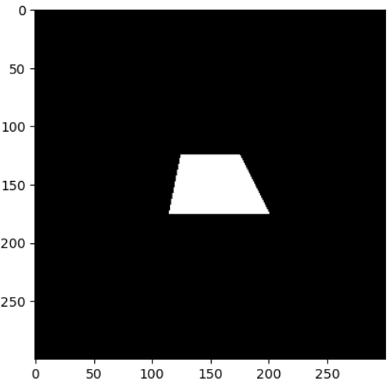

Quadrilateral After applying transformations:

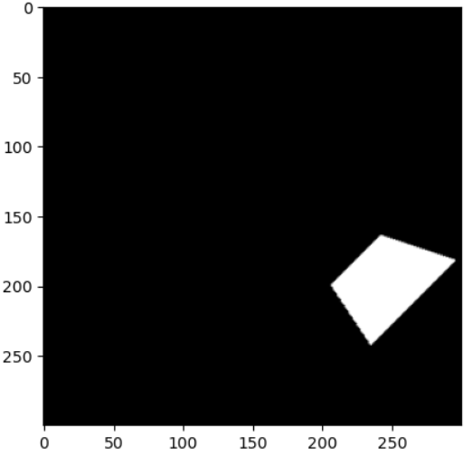

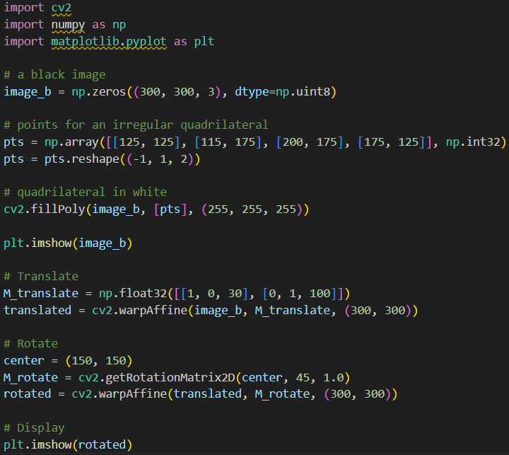

**Question 2-----------------------------------------------------**

**2.1 ,2.2, 2.3, 2.4-----------------------------------------------------**

Image A keypoints:

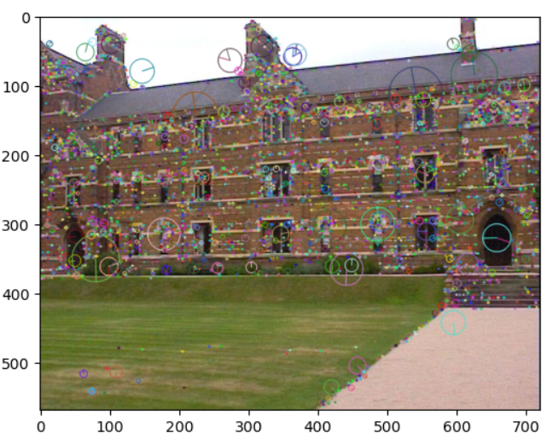

Image B keypoints:

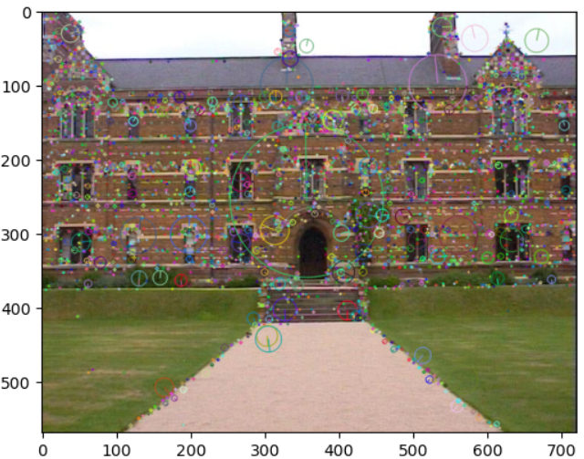

Image C keypoints:

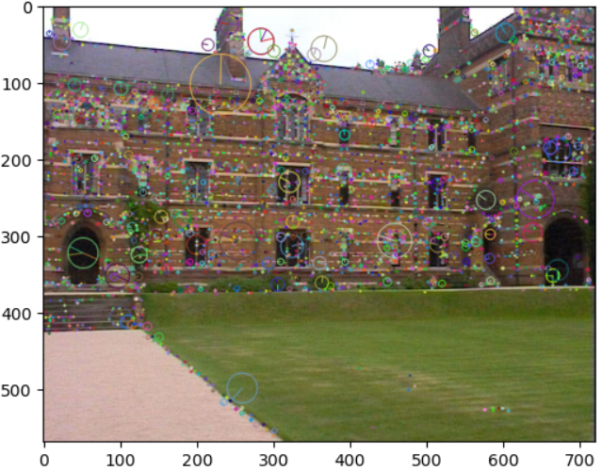

Matching features between Image A and Image B:

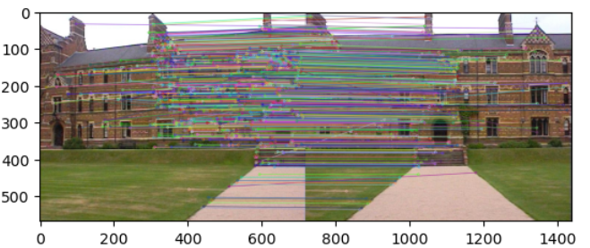

Matching features between Image B and Image C:

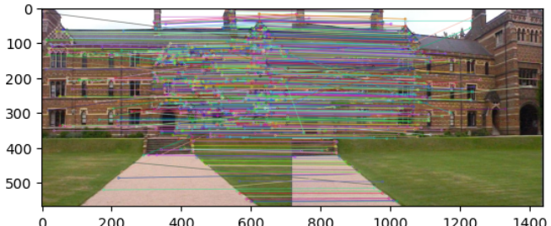

Keypoints of image A after similar matches:

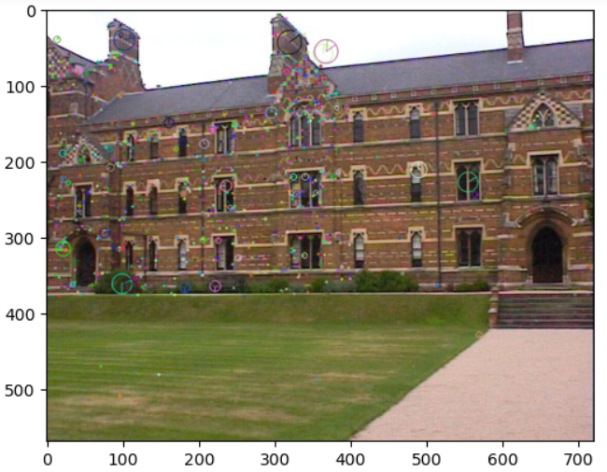

Keypoints of image B after similar matches:

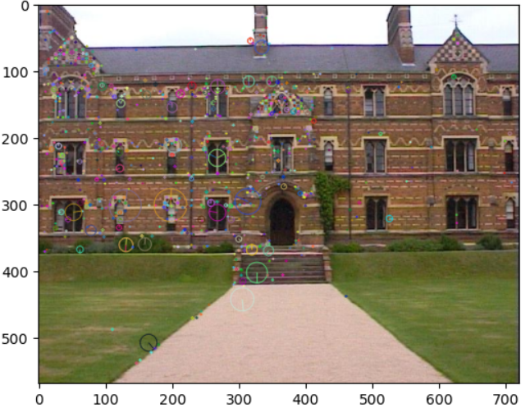

Keypoints of image C after similar matches:

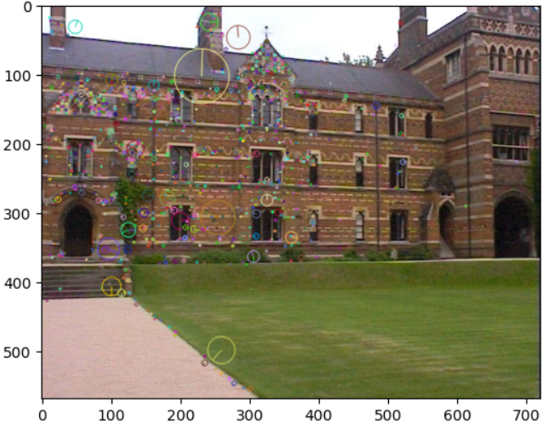

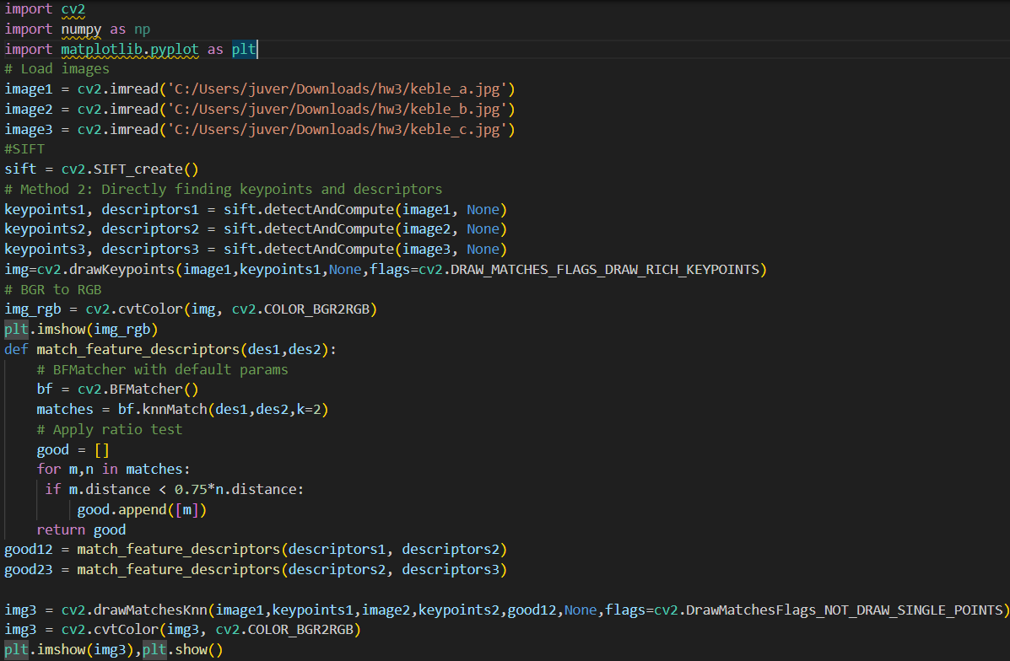

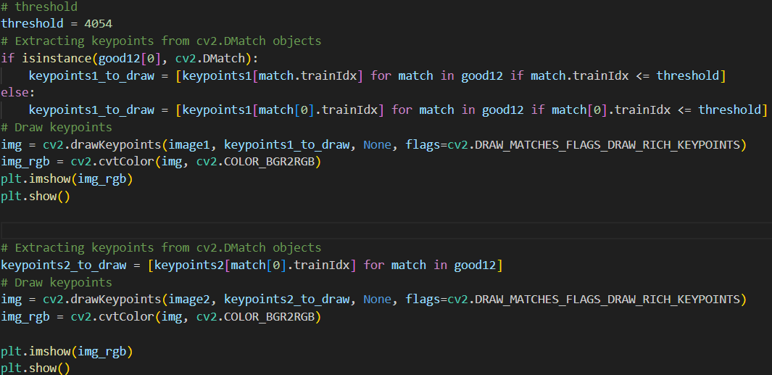

Image A warped perspective with the Homograph matrix:

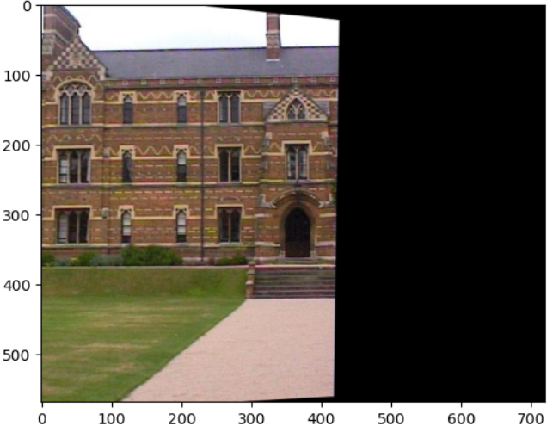

Image C warped perspective with the Homograph matrix:

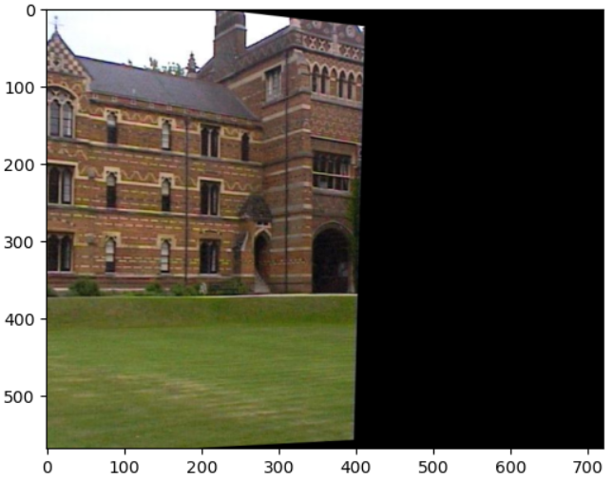

Stitching Image A and Image B:

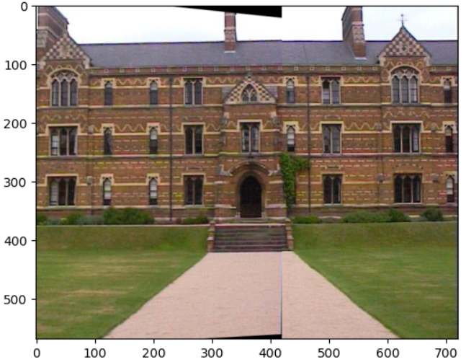Stitching Image B and Image C:

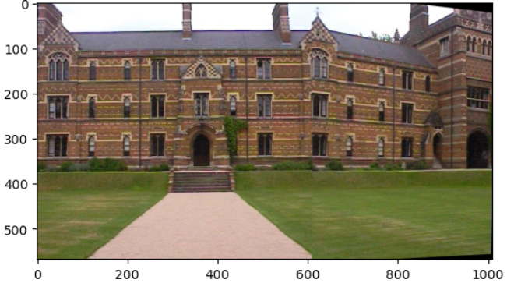

Creating Mosaic by stitching Image A,B,C:

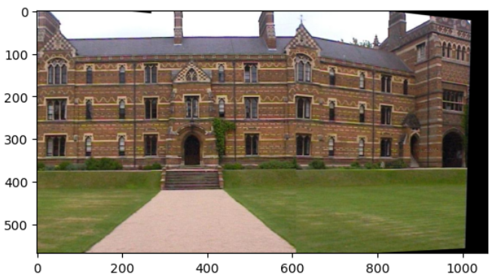

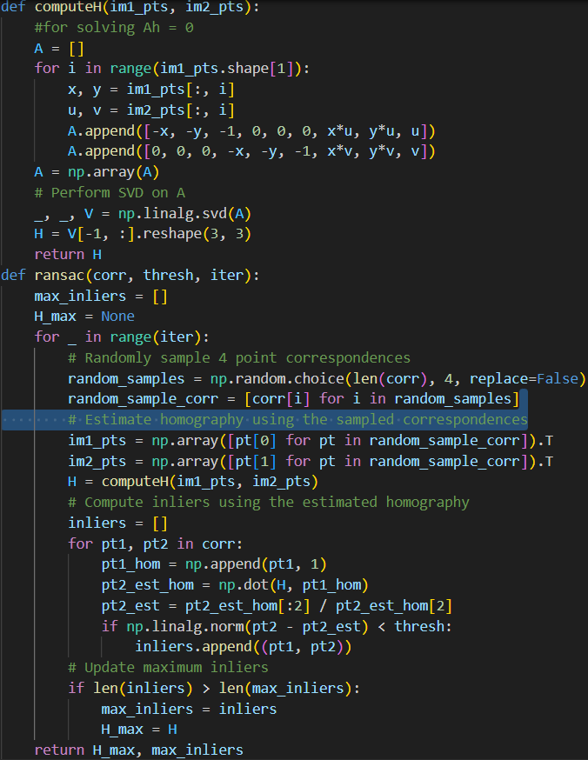

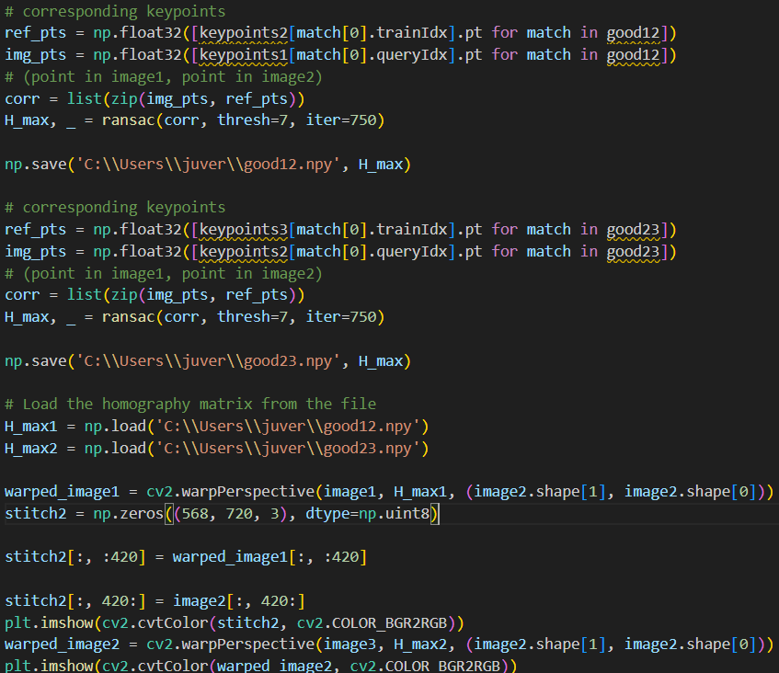

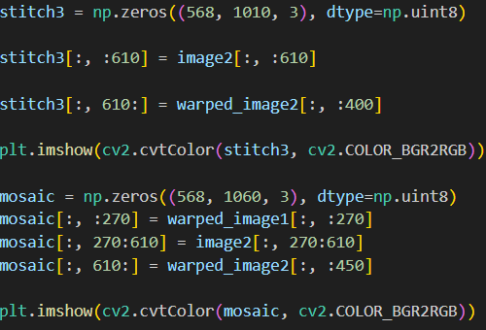

**2.5-----------------------------------------------------**

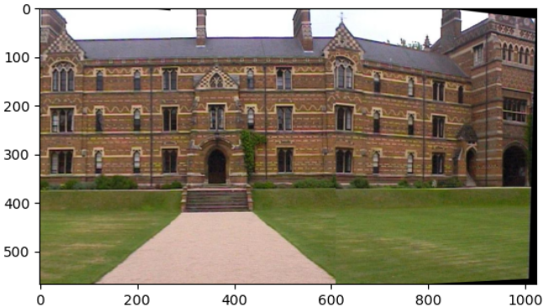

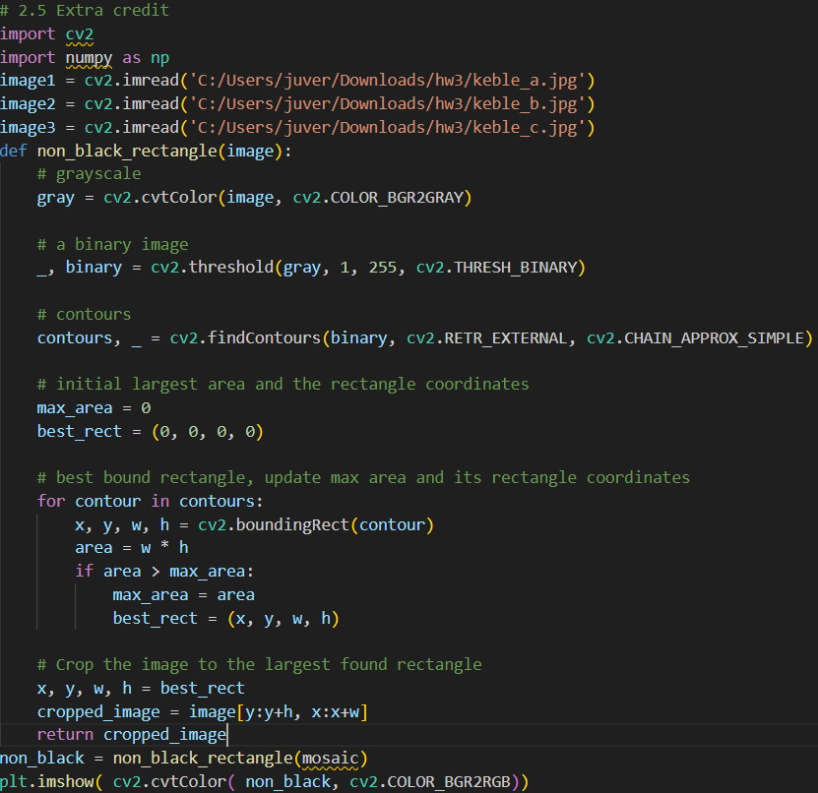

**2.6-----------------------------------------------------**

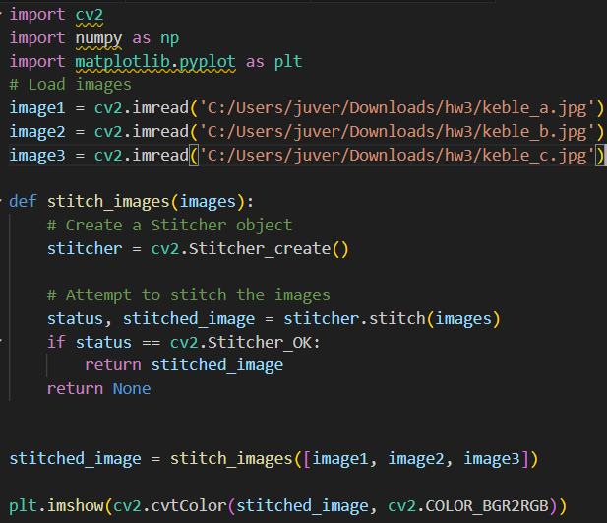

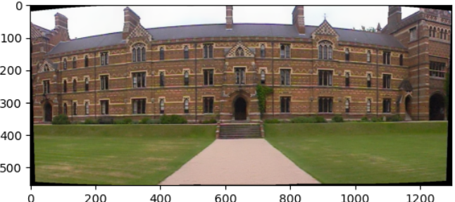

**Technical Differences:**

For my approach, I have used SIFT for keypoints and descriptors. The OpenCV Stitcher uses built-in Stitcher algorithms which can be ORB and these robusts methods are tuned to get fine results which is not the case where I implemented.

Theres a difference in using the feature matching too. I have used default BFMatcher whereas OpenCV Stitcher uses multi-band blending for smooth transitions.

For the Homography estimation too, I have limited the iterations and threshold, the in-built optimizes and uses the parameters efficiently.

The image blending techniques are advanced in the OpenCV stitcher compared to my approach because of the usage of multi-band blending.

**2.7-----------------------------------------------------**

Keypoints:

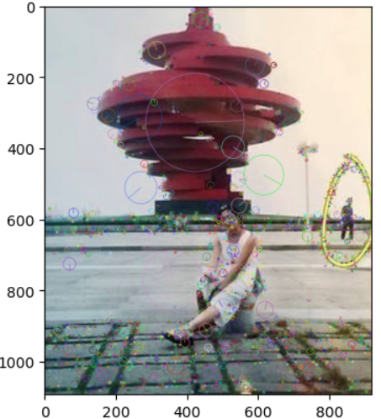

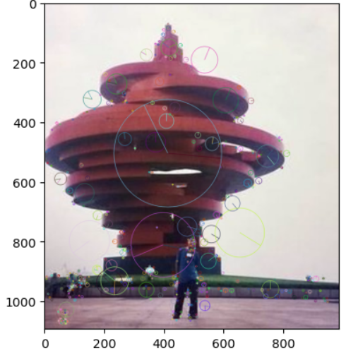

Match Features:

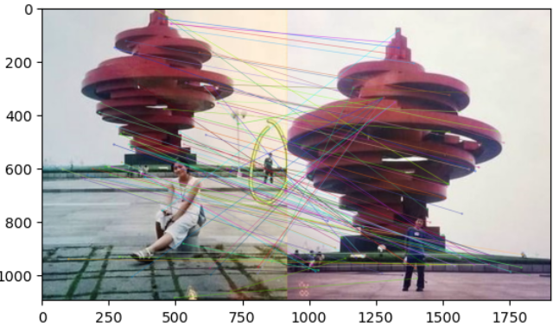

Homographies:

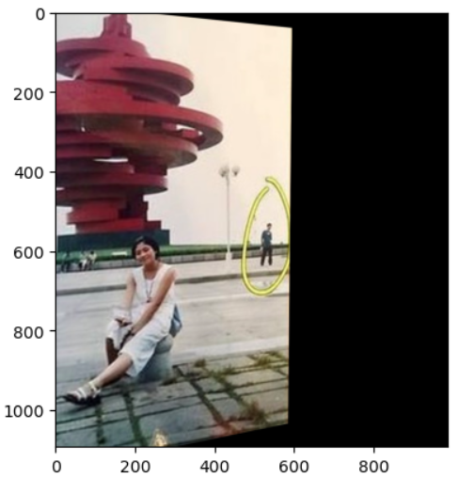

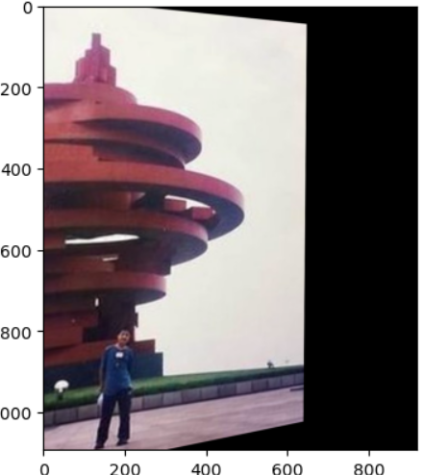

Stitching:

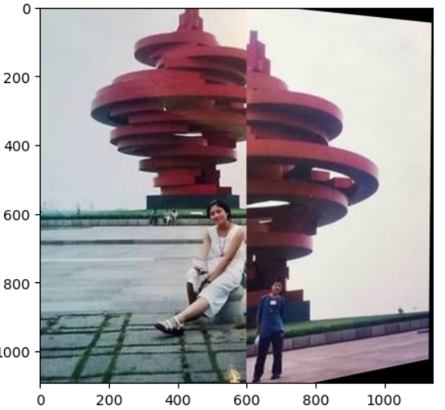

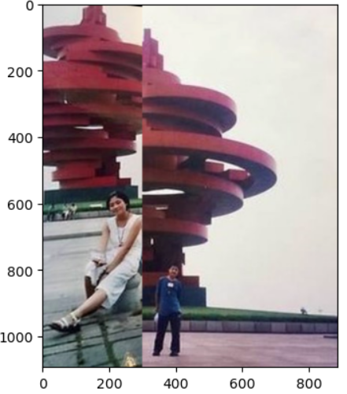

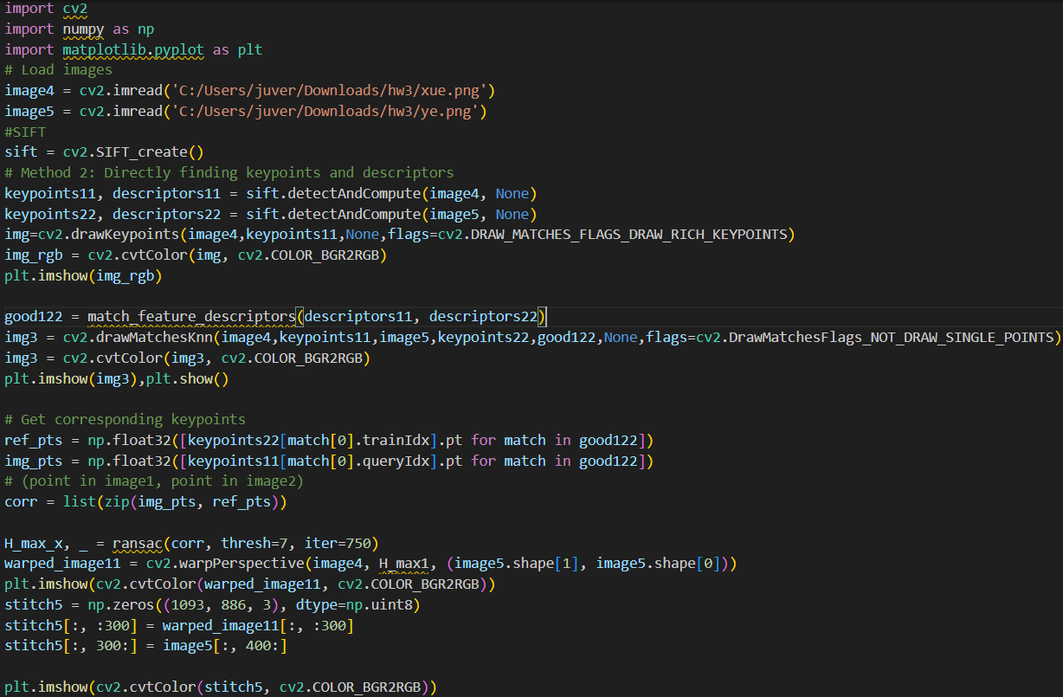

References:

[1] [s11263-006-0002-3.pdf (springer.com)](https://link.springer.com/content/pdf/10.1007/s11263-006-0002-3.pdf)

[2] [OpenCV: Introduction to SIFT (Scale-Invariant Feature Transform)](https://docs.opencv.org/4.x/da/df5/tutorial_py_sift_intro.html)

[3] [OpenCV: Feature Matching](https://docs.opencv.org/4.x/dc/dc3/tutorial_py_matcher.html)

[4] [homography_estimation.pdf (ucsd.edu)](https://cseweb.ucsd.edu/classes/wi07/cse252a/homography_estimation/homography_estimation.pdf)

[5] [OpenCV: Images stitching](https://docs.opencv.org/3.4/d1/d46/group__stitching.html)

[6] Matthew Brown, Richard Szeliski, and Simon Winder. Multi-image matching using multi-scale oriented patches. In 2005 IEEE Computer Society Conference on Computer Vision and Pattern Recognition (CVPR’05), volume 1, pages 510–517. IEEE, 2005. 2

[7] [Matplotlib — Visualization with Python](https://matplotlib.org/)

[8] [Python Documentation contents — Python 3.12.2 documentation](https://docs.python.org/3/contents.html)

[9] [NumPy –](https://numpy.org/)

[10] [OpenCV - Open Computer Vision Library](https://opencv.org/)

[11] [Lecture 5: Image Features (umbc.edu)](https://redirect.cs.umbc.edu/courses/graduate/691cv/lectures/05_image-features.pdf)

[12][12_homographies.pdf (umbc.edu)](https://redirect.cs.umbc.edu/courses/graduate/691cv/lectures/12_homographies.pdf)

[13][13_camera-models.pdf (umbc.edu)](https://redirect.cs.umbc.edu/courses/graduate/691cv/lectures/13_camera-models.pdf)